Steps for full deployment

1. Build the Spring Boot application to generate the JAR file:
mvn clean package

Create a docker file for your backend
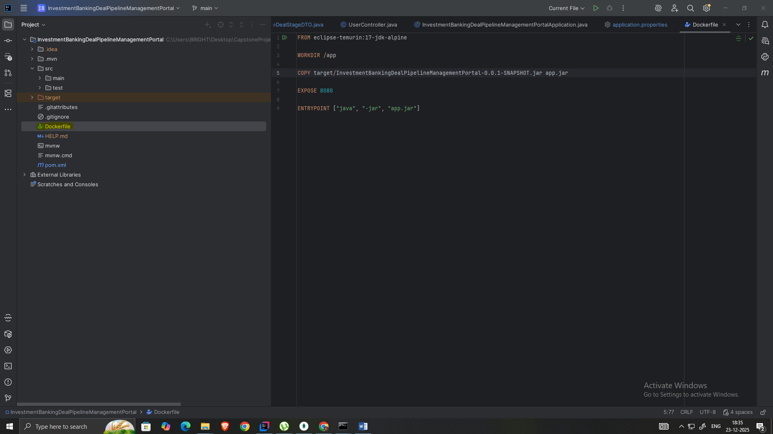

2. Build Angular for production:
ng build --prod --output-path=dist/browser

Create a docker file for the frontend
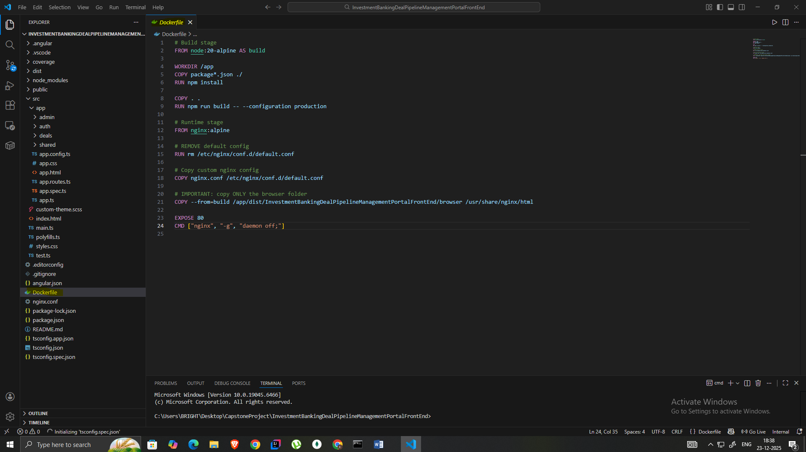

4. Create a ngnix config file to act as a reverse proxy to frontend(angular) and backend(spring boot)
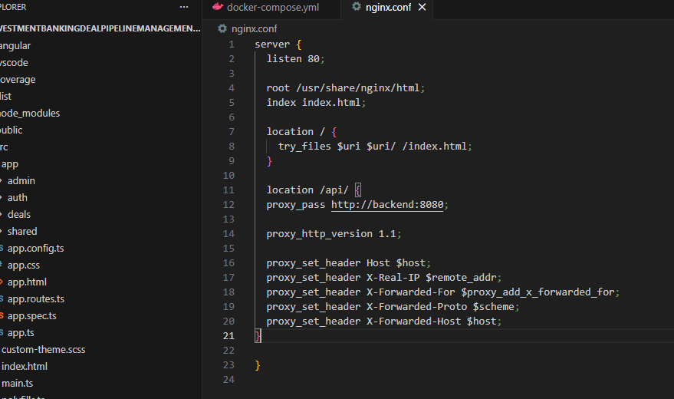

5. Create a docker-compose file to integrate the frontend and backend at the root folder
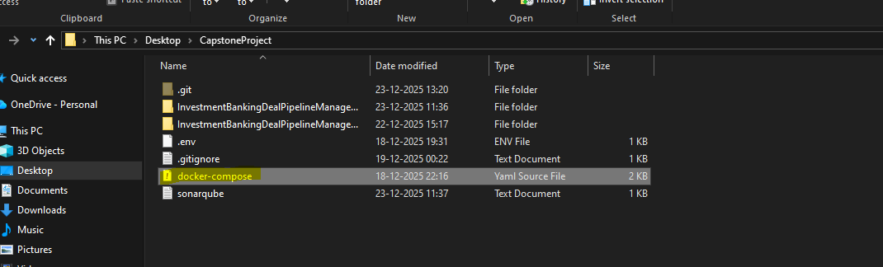
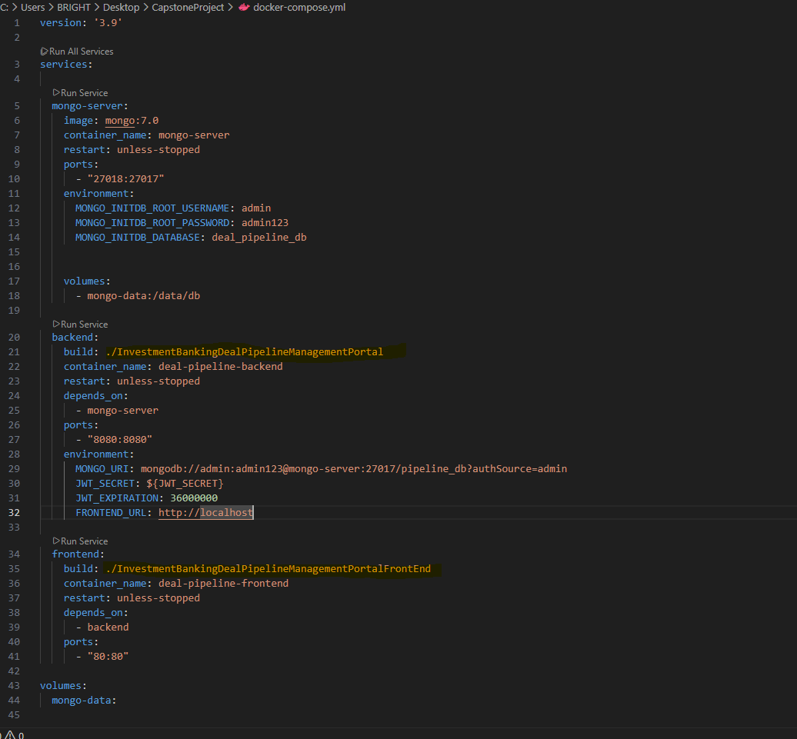

6. Then run the command docker-compose up –d
Verify running containers:
docker ps

7. Tag Docker Images
After containers are built, tag the images:
docker tag deal-frontend:latest username/deal-pipeline-frontend:1.0
docker tag deal-backend:latest username/deal-pipeline-backend:1.0
8. Push Images to Docker Hub
Login to Docker Hub:
docker login
Push images:
docker push username/deal-pipeline-frontend:1.0
docker push username/deal-pipeline-backend:1.0
9. Create Production Docker Compose (Image-Based)
Create a new docker-compose.yml using only image tags:
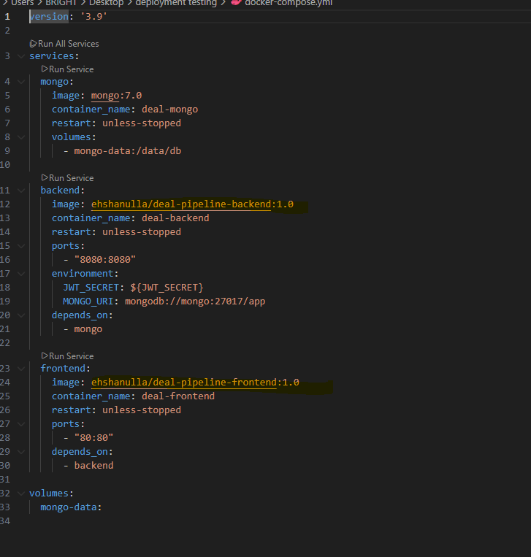

10. Deploy Anywhere
Run on any machine with Docker installed:
docker-compose up -d

